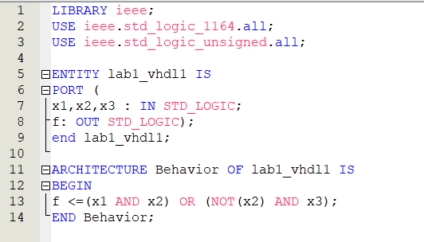

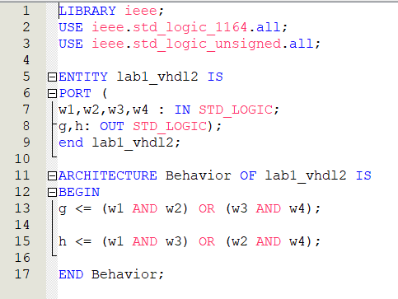

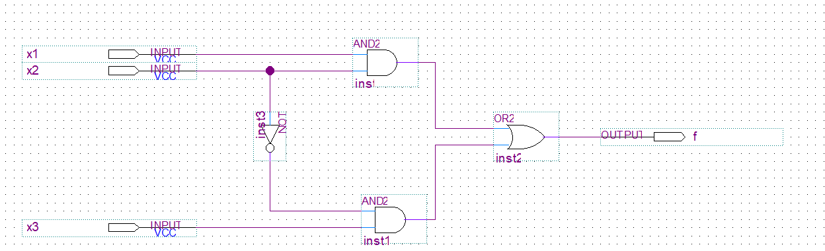
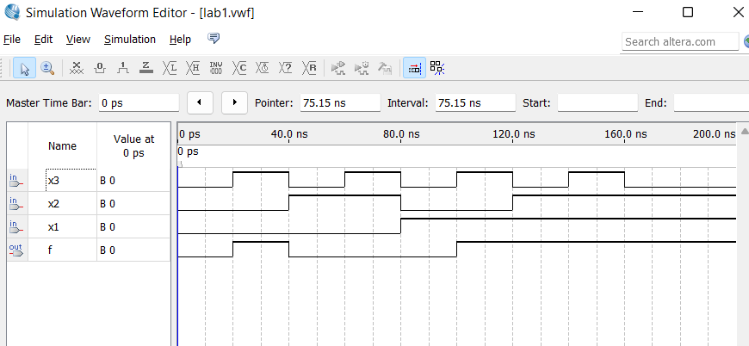

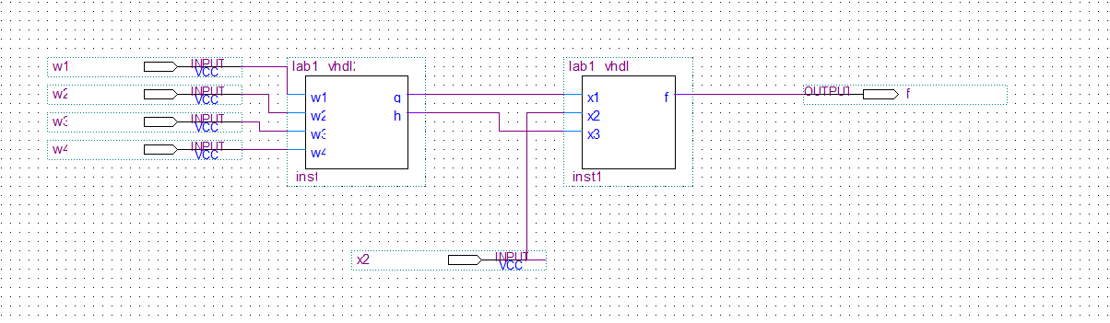
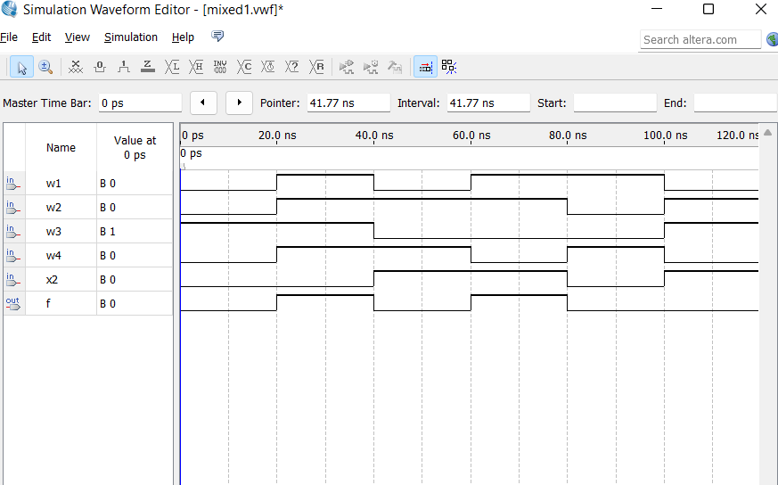

Conclusion:
In this lab I learned how to use CAD tools to design, compile, and simulate block diagrams schematics and VHDL-based designs using the Quartus II software. I got familiar with Quartus II by reading the tutorial and by performing all the steps in the lab manual. First, I made a schematic design which I later compiled and then simulated that design. The simulations were displayed in waveforms which took all the inputs and resulted in the output of the design. I also learned how to create a logical circuit design by writing VHDL code. Overall, this should help in my future labs where I will need to know how to pilot Quartus II.

